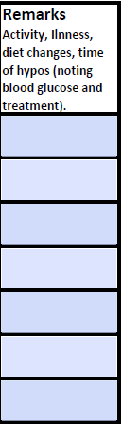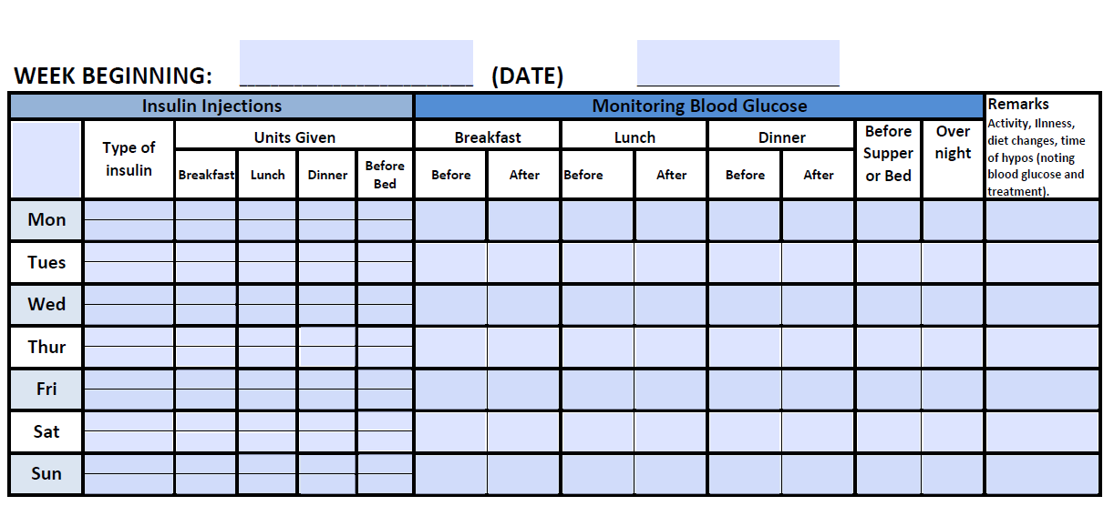

**Remarks / Comments**

E.g. activity, illness, diet changes, time of hypos (noting blood glucose and treatment).

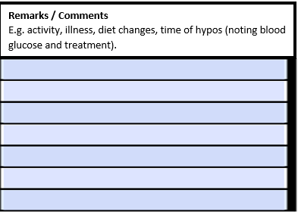

Free Diabetes log books are no longer available. As you know, record keeping continues to be important part of review of diabetes care.

An editable chart for families to print and record 4 weeks of insulin and blood glucose data can be found on the following link:

[https://www.novonordisk.com.au/patients/diabetes-care/blood-glucose-record-form.html](C:\\Users\\mourade\\Documents\\Outlook Files)

There are also a number of apps available for record keeping - some are free and others have monthly fees.